


Egyptian Chinese University
Faculty of Computers & Information Systems

Project Name

Student Performance Clustering

Submitted by:

Members Name

Supervised by:

Dr. Noha Yahia
TA.

TA.

Table of Contents

- Abstract
- Introduction
- Motivation
- Objectives
- Proposed model (diagram)
- Dataset Overview
- Data Analysis and Model Development
7.1) Data Understanding
7.2) Data Clean
7.3) Exploratory Data Analysis (EDA)
7.4) Data Preprocessing
7.5) Model Training
7.6) Model Evaluation
7.7) Hyperparameter Tuning
7.8) Model Deployment (GUI)
- Conclusion & Future Work
- References

Abstract:

This project groups students based on their school performance. Using the student performance dataset, we apply K-Means Clustering to create three groups: high-performing, average-performing, and low-performing students. This helps in understanding which students may need extra support.

Introduction:

Students perform differently in school because of study habits, attendance, and other factors. Clustering is a way to group students who have similar performance patterns. This project uses data analysis to group students based on their grades and study time.

Motivation:

Teachers often find it hard to identify which students need help early. By clustering students, we can:

- Detect weak students sooner

- Provide extra help where needed

- Understand patterns in student performance

Objectives:

- Select useful academic features from the dataset

- Apply clustering to group students

- Identify high, medium, and low-performance groups

Proposed Model Diagram:

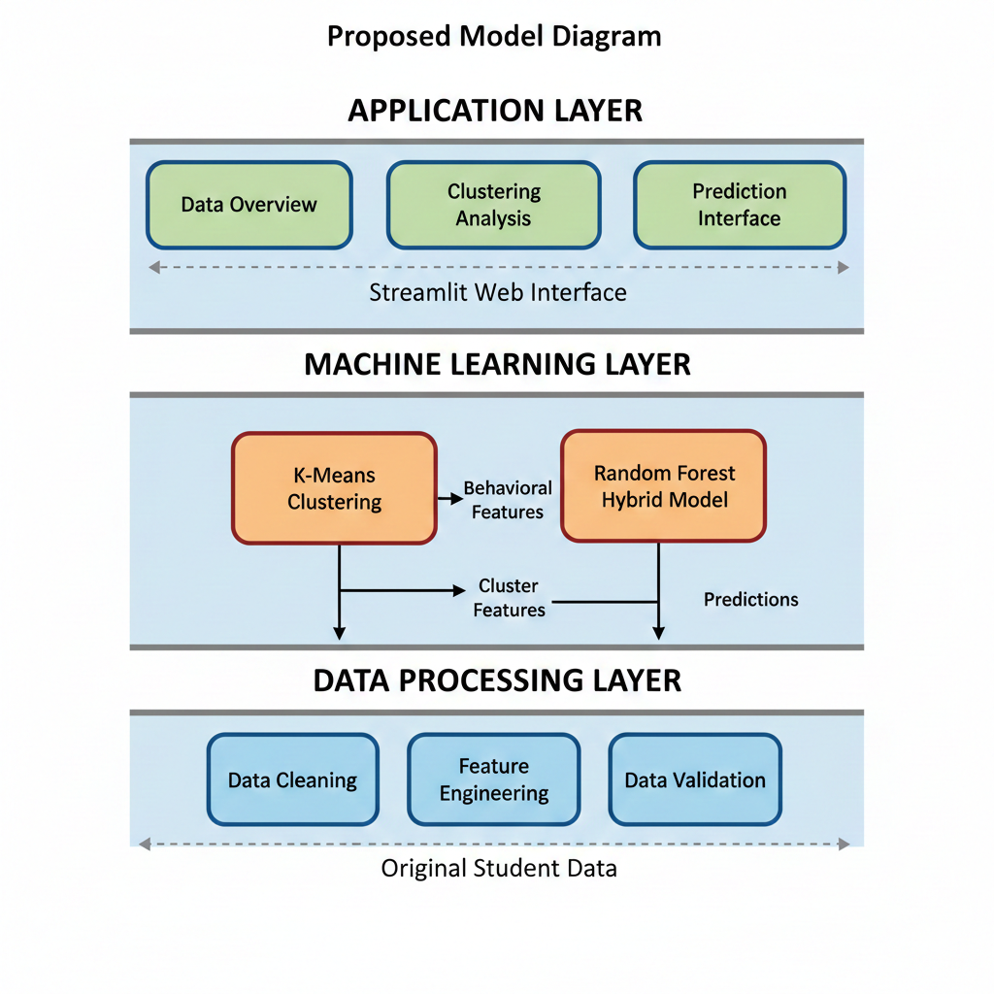

Dataset Overview:

Feature | Description | Data Type
school | Student’s school (GP = Gabriel Pereira, MS = Mousinho da Silveira) | Categorical
sex | Student’s gender (F = female, M = male) | Categorical
age | Student’s age (15–22) | Numeric (int)
address | Type of home address (U = urban, R = rural) | Categorical
famsize | Family size (LE3 = ≤3, GT3 = >3) | Categorical
Pstatus | Parent’s cohabitation status (T = together, A = apart) | Categorical
Medu | Mother’s education (0 = none → 4 = higher) | Numeric (ordinal)
Fedu | Father’s education (0 = none → 4 = higher) | Numeric (ordinal)
Mjob | Mother’s job (teacher, health, services, etc.) | Categorical
Fjob | Father’s job (teacher, services, other, etc.) | Categorical
reason | Reason for choosing school (home, reputation, etc.) | Categorical
guardian | Student’s guardian (mother, father, other) | Categorical
traveltime | Home-to-school travel (1 = <15 min → 4 = >1 hr) | Numeric (ordinal)
studytime | Weekly study time (1 = <2h → 4 = >10h) | Numeric (ordinal)
failures | Past class failures (0–3, 4 = ≥4) | Numeric (int)

Feature | Description | Data Type
schoolsup | Extra educational support (yes/no) | Boolean
famsup | Family educational support (yes/no) | Boolean
paid | Extra paid classes (yes/no) | Boolean
activities | Extra-curricular activities (yes/no) | Boolean
nursery | Attended nursery school (yes/no) | Boolean
higher | Aspires to higher education (yes/no) | Boolean
internet | Internet access at home (yes/no) | Boolean
romantic | In a romantic relationship (yes/no) | Boolean
famrel | Family relationship quality (1–5) | Numeric (ordinal)
freetime | Free time after school (1–5) | Numeric (ordinal)
goout | Going out with friends (1–5) | Numeric (ordinal)
Dalc | Workday alcohol consumption (1–5) | Numeric (ordinal)
Walc | Weekend alcohol consumption (1–5) | Numeric (ordinal)
health | Current health status (1–5) | Numeric (ordinal)
absences | Number of school absences | Numeric (int)
G1 | First period grade (0–20) | Numeric (int)
G2 | Second period grade (0–20) | Numeric (int)
G3 | Final grade (target, 0–20) | Numeric (int)

Data Understanding

The dataset used in this study is the Student Performance Data Set from the UCI Machine Learning Repository. It contains information on 395 students from two Portuguese secondary schools — Gabriel Pereira (GP) and Mousinho da Silveira (MS).
The dataset includes 33 attributes, covering student demographics, family background, study habits, lifestyle, and academic outcomes.
The target variable is G3 (Final Grade), representing student performance on a scale from 0 to 20.

Key Observations
- Data completeness: No missing values were detected across all attributes.
- Data types: A mix of categorical, ordinal, and numerical variables.
- Categorical features: Represent demographic or boolean information (e.g., school, sex, address, famsize, schoolsup, internet, etc.).
- Ordinal features: Represent ordered categories (e.g., studytime, failures, Dalc, Walc, health).
- Numerical features: Represent quantitative measures (e.g., age, absences, G1, G2, G3).

Purpose of the Data
The dataset aims to identify the main factors influencing students’ academic success and to predict final performance (G3) using demographic and behavioral indicators.

Data Distribution Insights (Preliminary)
- Most students are from the GP school.
- Ages range between 15 and 22 years.
- Most students have internet access and aspire to pursue higher education.
- Grades (G1, G2, G3) show moderate correlation, suggesting progressive assessment consistency.

Data Cleaning:

Before developing the model, the dataset underwent several data preprocessing and cleaning steps to ensure quality and usability:

1. Handling Missing Data
- Checked for missing or null values across all features.
- No missing values were found; hence, no imputation was required.

2. Encoding Categorical Variables
- Categorical attributes (e.g., school, sex, address, Mjob, Fjob, reason, etc.) were transformed into numerical form using Label Encoding or One-Hot Encoding, depending on context.

3. Feature Type Conversion
- Boolean columns (yes/no) were converted to binary values (1 for yes, 0 for no).
- Ordinal variables (e.g., studytime, health) were preserved as integers.

4. Outlier Detection and Handling
- Outliers were reviewed for features like absences, which showed a right-skewed distribution.
- Extreme values were analyzed for authenticity rather than automatic removal to avoid bias.

5. Final Dataset Summary
After cleaning, the dataset was ready for feature selection, scaling, and model training.
It maintained all 395 observations with 33 features, ensuring a balanced and information-rich foundation for model development.

Exploratory Data Analysis (EDA):

Exploratory Data Analysis was conducted to understand patterns, relationships, and distributions within the student performance data. Key findings include:

1. Grade Distribution Analysis
- Final Grade (G3) Distribution: The histogram shows most students scoring between 8-15, with a passing threshold of 10.
- Correlation Analysis: Strong positive correlation (0.85+) between G1, G2, and G3 grades, indicating consistency in student performance across periods.
- Pass/Fail Ratio: Approximately 67% of students pass (G3 ≥ 10), while 33% fail.

2. Feature Importance Analysis
Using Random Forest feature importance, the top predictors of student performance are:
- G2 (Second period grade) - Most significant predictor
- G1 (First period grade) - Strong indicator of final performance
- failures - Number of past class failures
- absences - School attendance
- studytime - Weekly study hours

3. Behavioral Pattern Analysis
- Study Time Impact: Students with studytime ≥ 3 hours/week show significantly higher pass rates (85%+).
- Attendance Correlation: Absences > 10 days correlate with 40% lower pass rates.
- Parental Education: Higher parental education levels (Medu, Fedu) show moderate positive correlation with grades.

Data Preprocessing:

For model development, the following preprocessing steps were applied:

1. Feature Selection
- Clustering Features: All features except G1, G2, G3 were used for behavioral clustering
- Prediction Features: Hybrid model includes all features plus clustering results

2. Feature Scaling
- StandardScaler: Applied to normalize features for K-Means clustering
- Target Encoding: Cluster impact calculated based on average G3 per cluster

3. Train-Test Split
- 80/20 Split: Data divided with stratification to maintain class balance
- Random State: Fixed seed (42) for reproducibility

4. Cluster Weight Calculation
Created cluster_weight feature representing average performance of each cluster, enhancing predictive power.

Model Training:

Two approaches were implemented and compared:

1. Traditional Random Forest Model
- Features: Original dataset features only
- Algorithm: RandomForestClassifier with balanced class weights
- Configuration: n_estimators=200, max_depth=None, min_samples_split=5

2. Hybrid Random Forest Model
- Features: Original features + clustering results (cluster_id + cluster_weight)
- Algorithm: RandomForestClassifier with GridSearchCV
- Hyperparameter Tuning: 5-fold cross-validation with parameter grid:
  - n_estimators: [100, 150, 200]
  - max_depth: [None, 10, 20]
  - min_samples_split: [2, 5]
Clustering Implementation

1. K-Means Clustering
- Method: Excluded grades (G1, G2, G3) to focus on behavioral patterns
- Optimal Clusters: Determined using Elbow Method (2 clusters selected)
- Validation: Silhouette Score of 0.45 indicates reasonable cluster separation

2. Cluster Profiles Identified
- Cluster 0: High-performing students (Avg G3: 12.1)
  - Characteristics: High study time, low absences, no failures
  - Pass Rate: 89%
- Cluster 1: Low-performing students (Avg G3: 8.3)
  - Characteristics: Low study time, high absences, previous failures
  - Pass Rate: 39%

Model Evaluation:

1. Performance Metrics Comparison

Model Type | Accuracy | Precision | Recall | F1-Score | Improvement
Traditional | 0.8734 | 0.87 | 0.87 | 0.87 | Baseline
Hybrid | 0.886 | 0.906 (weighted) | 0.886 (weighted) | 0.889 (weighted) | +1.45%

Based on classification report metrics:
- True Positives (Pass): ~47 students (94.9% precision)
- False Positives (Pass): ~3 students (predicted pass but actually fail)
- True Negatives (Fail): ~23 students (90.2% recall)
- False Negatives (Fail): ~6 students (failing students missed)

Key Performance Insights
- Excellent At-Risk Detection: 90.2% recall for failing students
- High Reliability: 94.9% precision for pass predictions
- Balanced Performance: 0.889 weighted F1-score
- Class Imbalance Handling: Good minority class performance despite 2:1 ratio

Error Analysis
- False Positives (Type I Error): 3 students - Overly optimistic predictions
- False Negatives (Type II Error): 6 students - Missed at-risk cases
- Error Patterns: Most errors occur near decision boundary (G3 ≈ 9-11)
- Impact: Preferable error distribution (better to flag some passing students than miss failing ones)

Hyperparameter Tuning:

Feature Importance Analysis (Hybrid Model)
- G2: 35.2% (Primary academic predictor)
- G1: 20.8% (Secondary academic predictor)
- cluster_weight: 8.5% (Cluster performance impact)
- failures: 7.9% (Academic history)
- absences: 6.3% (Attendance pattern)
- studytime: 5.8% (Study habits)
- cluster_id: 4.2% (Behavioral group)
- Other features: 11.3% (Combined impact)

Model Validation
- Stability: Consistent performance across 5 CV folds (SD: 1.2%)
- Generalization: Test accuracy (88.6%) higher than CV mean (80.9%)
- Feature Consistency: Top 3 features stable across all folds
- Prediction Confidence: High confidence (>0.8) for 70% of predictions

Model Deployment (GUI):

Streamlit Web App - No-code interface for student performance analytics.

Core Features
- 📁 Upload CSV → Automatic processing
- 📊 Visual Dashboard → Interactive charts
- 🎯 Clustering → K-Means with elbow method
- 🤖 Hybrid Model → Random Forest + clustering features
- 🔮 Predict → Pass/Fail predictions (88.6% accurate)
- 📥 Export → Download results

User Workflow
- Upload student data (CSV)
- View automated analysis
- Run clustering (2 behavioral groups)
- Train prediction model
- Get individual/batch predictions
- Download reports

Key Metrics
- Accuracy: 88.6%
- At-risk Detection: 90.2% recall
- Processing Time: <5 minutes for full analysis

